**LAB 02**

**BASIC CONFIGURATION OF A SWITCH**

In this lab, you'll learn to use a basic configuration on a Cisco switch, using IOS commands.

1. Download “Lab 02 - Basic configuration of a Cisco switch.pka” from Leho
2. Open this PKA file in PT. (Fill in your Cisco credentials when opening PT).
3. Drag following items into your PT work space: a desktop PC (‘PC-PT’, not a ‘Wireless PC’) and a switch (‘2960’, not any other switch).

Leave the default names (‘PC0’ and ‘Switch0’) untouched throughout the lab.

It should look like this:

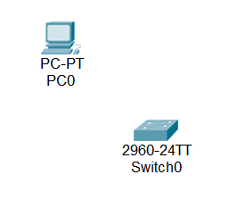

1. We're going to set up a basic configuration for the switch, and this from the PC. To do this you must first create a console connection between the **serial port of the PC** **(RS 232)** and the **console port of the switch**.

Which cable do you need to use for this? (name and color)

A blue console cable

Note: today you rarely find modern computers still equipped with a serial port. You’ll most likely will need to use a serial-to-USB converter. Your USB-TTL cable you’ve used to connect your RPI in HDOS is actually also a serial-to-USB converter.

1. **Open the built-in terminal emulator application on the desktop PC** and agree to the proposed settings to connect to the switch.
2. You will be connected immediately to the OS of the switch (which is called “IOS” by Cisco). Press the Enter key. IOS then shows by a prompt that it is ready to receive IOS commands.

IMPORTANT NOTE: In PT, you can also configure a switch (or other intermediary devices) by simply clicking on it and then choosing the Config or CLI tab. In reality, of course, you don’t have a built-in keyboard/screen on switches/routers. So in real life you have to do the initial basic configuration using a console connection. For this reason, on Cisco exams and within this course we will often disable the features to configure a switch by simply clicking on it.

1. The IOS prompt consists of the name of the device (in our case: Switch), followed by a larger-than-character (>).With this larger-than-sign, IOS indicates that you are currently in **User Exec mode**. In this mode you don‘t have many commands and you can’t do that much either.

To get a list of all the commands you can use in this mode, **type a question mark (?)**.

Is there a command to erase the screen?

No

Show all commands starting with the letter t.

t?

If you type a non-existent command, IOS will consider this to be a DNS lookup, and you will have to wait a long time before you can continue.

**Tip: in such a situation, use the Ctrl-Shift-6 key to abort it! Remember this key combination!**

Try this!

1. A common command in User Exec mode is the command ***show***. Type this command and press Enter.

Note that you get an error message “incomplete command” because this command must be followed by at least one parameter (keyword).

What do you need to type to display all the parameters that can be used with the show command?

show ?

Look at this info and now use show with the correct parameter to get information about the interfaces of your switch.

show interfaces

Because the switch has many interfaces, not all info can be displayed on 1 screen. Which key do you need to press to view the next screen?

The spacebar

Which key do you have to press to abort your command?

CTRL+c

1. In IOS you can limit yourself to typing the first letters of commands and parameters, rather than typing the full command (call it laziness 😉). Test this by using the shortest possible version of the previous command.

s in

Note: if unclear due to multiple possibilities (you abbreviated the command too much), you will get an error message about an “Ambiguous command”.

1. Since we will certainly not be able to configure anything in User Exec mode, we will switch to **Privileged EXEC** mode.

**Remember: with *enable* (or shorter: *en*) you switch from User EXEC to Privileged EXEC mode.**

How do you notice that you are now in Privileged EXEC mode?

The ‘#’ symbol is now showing

Check which commands you can use in this mode.

?

Note that you have many more commands here than in User Exec mode.

1. Note that the show command in Privileged EXEC mode has additional parameters. In this mode, you can retrieve the contents of the **current configuration** file of the switch. Write down the shortest possible version of your command below.

su ru

How many Ethernet ports does the switch have according to this configuration file?

26 ethernet ports (24x 100 Mbps and 2x 1Gbps)

Note that you can verify this by “looking at the switch” à look in PT at the tab ‘Physical’ at the switch.

1. As with Windows and Linux, you can navigate up and down arrow keys through command history in IOS and you can use the tab key for autocompletion (when it’s not ambiguous) of commands. Test all of this!
2. To make changes to the configuration of the switch, we need to switch to another mode, which is the **Global Configuration mode**.

**Remember: use the *configure terminal* command (or shorter: c*onf t*) to switch from “Privileged EXEC” to “Global Configuration mode”.**

**Note: with the ‘exit’ command you leave Global Configuration mode**

How do you notice that you are now in Global Configuration mode?

You can see Switch(config)#

Check which commands you can use in this mode.

?

Use the information below to give the switch the hostname “*switch-firstname”* (in which you replace my first name with your first name). Note: don’t change the “Switch0” label of the switch in the PT work space, but only change its hostname within the IOS operating system.

hostname switch-stef

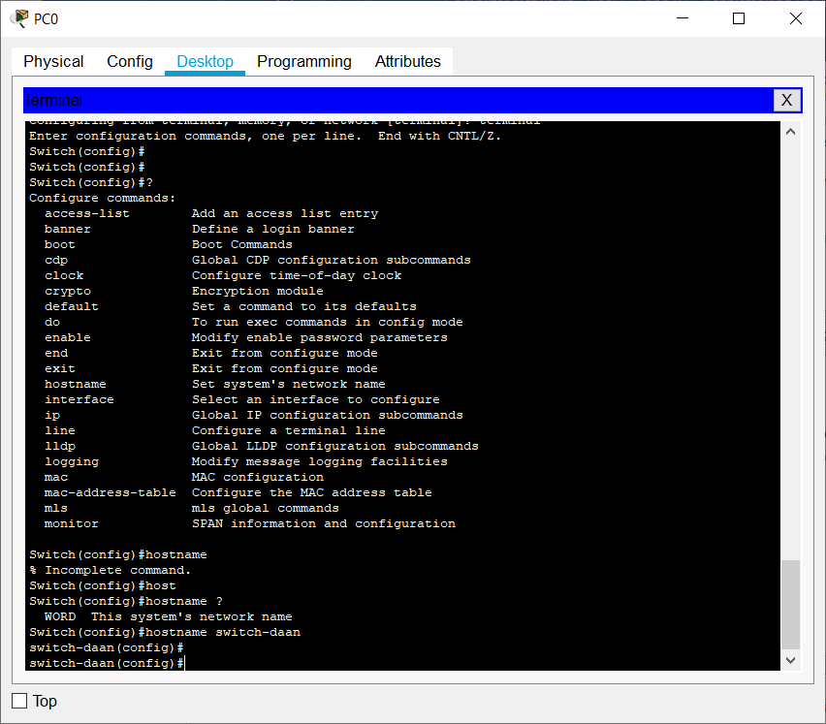

Note that the change in hostname is immediately included in the prompt character!

1. Remember that you could need to wait a long time if you have entered a wrong IOS command. You can avoid this by pressing Ctrl-Shift-6 after entering your wrong command, but you can also make sure that IOS will no longer try to “translate” your wrong command by default. This can be done by entering the command below in the Global Configuration Mode:

***no ip domain-lookup***

Type this command and then intentionally enter a wrong command to test its effect.

1. Normally, anyone who has physical access to the switch can access the switch via a console connection. A commonly used security measure is therefore to secure console access using a password.

To do this, you must first select the console connection in IOS. You do this with the command below:

***line console 0***

The number 0 indicates the first (and usually only) console access.

Note: now you’ll see “(config-line)” in your prompt instead of just “(config)”

Now that you are in the specific configuration mode of the console connection (“subconfiguration” mode instead of “global configuration” mode), you can use the command below to secure access to that console connection by setting the password *cisco* (this password -in lowercase- is often used as an example password throughout the Cisco course to secure access to the console).

***password cisco***

Finally, use the command below to enable password checking:

***login***

1. Let’s verify if this added security works. We’ll first have to close our active session on the console. Therefore, use the ‘**end**’ command or the key combination **Ctrl-z** or **Ctrl-c** to immediately go to Privileged EXEC mode (and thus skipping “Global Configuration mode”). Alternatively, use the ‘**exit**’ command twice to go from subconfiguration mode to global configuration mode and from global configuration mode to Privileged EXEC mode.

From Privileged EXEC mode, go to User EXEC mode with the ‘**disable**’ command. From there, close the session with the ‘**exit**’ command. (Or close the session immediately from Privileged EXEC mode with the ‘exit’ command.)

1. Now, press enter to start the session again. You’ll now be prompted for the password.

1. We are going to secure the access to the switch a little better by also protecting the access to the Privileged EXEC mode with a password. Use the following command in global configuration mode:

***enable secret class***

Note that throughout the Cisco course, the password *class* is taken to secure access to Privileged EXEC mode.

1. Verify the extra security is applied by going to User EXEC mode and then re-entering Privileged EXEC mode.
2. Check the configuration changes by requesting the contents of the current configuration file of the switch. You do this with the command below:

***show running-config***

Note that this is not possible in User EXEC mode nor in Global Configuration mode. So you will have to be in Privileged EXEC mode.

Check if you can access the contents of the current configuration file in this mode.

Yes

Note that the console password was stored in “clear text” (i.e. not hashed/encrypted), contrary to the password for Privileged EXEC!

1. To also store the console password encrypted, you need to use the command below (in Global Configuration mode) to enable the service which does that for you:

***service password-encryption***

1. As a final security measure, we're going to create a “deterrent message”. For this we use a **MOTD message** (**Message Of The Day**).

Set the following MOTD with this command (exactly this phrase):

***banner motd =Here I watch=***

Note that the "=” symbols are used as a separator for the MOTD.

Exit the console session to view the MOTD.

1. Finally, to avoid losing the current configuration settings of the switch (which are in the RAM memory) (e.g. by rebooting the switch or a sudden power failure), you have to copy the running-config file to the startup-config file using the command below. The latter is kept in the NVRAM (non volatile RAM) of the switch.

Please note: you can only run this command in the Privileged EXEC Mode!

***copy running-config startup-config (or shorter: copy ru st)***

Check that this has been achieved by requesting the contents of the startup-config file.

show startup-config

1. Restart the switch with the command below:

***reload***

After restarting, press the Enter key.

If you have everything configured correctly, you will have to enter a console password before you can do anything and enter a second password to access Privileged EXEC mode.

Test this out!

1. Save your PKA file as “**lastname-firstname-lab02.pka"** (in which you replace lastname and firstname of course with your own last name and first name) and upload it via Leho.